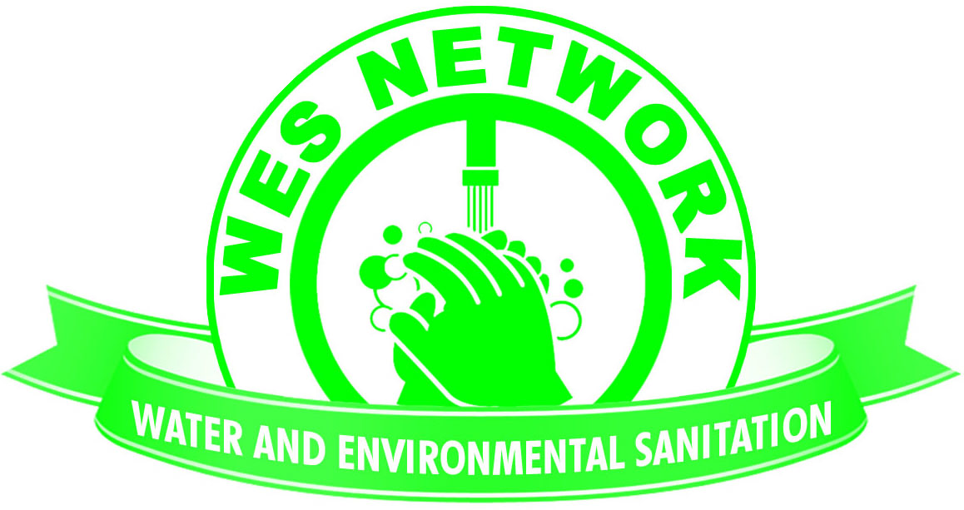

Terms of Reference for the Central Region Chapter of the Water and Environmental Sanitation Network

Overview of WES Network
WES Network is a member based organization that brings together NGOs working in the WASH sector striving to promote a high standard of service delivery for sustainable water and environmental sanitation in Malawi. The core objectives of WES Network are therefore:
- To act as the collective mouthpiece of NGOs operating in the Water and Environmental Sanitation sector;
- To build a positive and collaborative relationship between WES NGOs family and other stakeholders (Government, Donors, etc.) and to promote partnerships among them;
- To provide a research-backed common platform for advocacy in the WASH sector;
- To act as an independent advisor to the government on standard services, accountability and financing in the WASH sector;
- To promote adherence to high standards in provision of services in the water and sanitation sector in line with existing government policies; and
- To promote water and sanitation of the poor and underprivileged through civic education and other suitable means.

One of WES Network’s strategic sub-goals is to strengthen coordination amongst WASH partners by ensuring their active participation through network structures such as Thematic Working Groups, engagement through other sector activities, and as outlined in this document – Regional Chapters. Regional Chapters have been developed in each of the three regions of Malawi.
Objectives of the Central Regional Chapter
The following are the objectives of all Regional Chapters:
- To primarily encourage coordination amongst member organisations in the region by flagging up and avoiding duplication of activities, to identify key partnership opportunities amongst them, and for organisations working in the same area to share context-specific information;
- To create a space for knowledge sharing of best practices, successes and challenges, and new innovations and approaches, etc.;
- To formalize a link between the regional level and WES Network’s national level structures such as the Thematic Working Groups to provide updates and to promote gathering of feedback for those structures from the wider membership;
- To create a space for regionally-specific discussion and/or agendas relevant to the membership;
- To act as a platform whereby CSOs working at the lower levels may escalate unresolved inter-CSO conflicts if they may not be resolved at district level.
In the Central Region Chapter, members have opted to add the following specific objectives:
- These may be added as per minutes of the meeting of the central region chapter
Composition, Roles, and Responsibilities
Membership - All Civil Society Organisations with operations in the Central Region shall be considered members of the Central Region Chapter. Responsibilities of the membership include:
- To actively participate in meetings
- To indicate availability for quarterly meetings when an invitation is circulated
- To submit any pertinent agenda items to the secretariat prior to each meeting
- To take on chairing member duties at least once in a two year period
Chairing member - The chair of the chapter shall be a member organization and will rotate with each quarterly meeting. Member organisations may also pair up to share the responsibilities. Responsibilities of the chairing member(s) include:
- To liaise with the secretary to determine the date and location of the upcoming chapter meeting
- To host the meeting at their office premises or to otherwise arrange a meeting venue at their expense
- To chair the meeting and to ensure the selection of the next chairing member
- To hand over any relevant information to the next chairing member and the secretary
Secretary – WES Network secretariat shall act as the secretary of the group. Responsibilities of the secretary include:
- To initiate the planning process with each chairing member prior to each quarterly meeting
- To take detailed minutes or to delegate a member organization to do so accordingly
- To request any agenda items from the member of the chapter prior to the meeting
- To ensure a set agenda is followed, allowing for addition of relevant agendas flagged up by the membership
- To send invitations to the regional members and to invite regional government representation if appropriate
- To keep an updated contact list for the regional chapter
External representatives – The Regional representatives from government (eg. Regional Irrigation and Water Development Office) may be invited to chapter meetings for the sake of coordination and transparency, except in the case where a proposed agenda item may require a closed-door approach. Other external representatives may be invited on a case-by-case basis on the discretion of the members and the secretary, for example representatives from private businesses, Parliamentarians, donors, etc.

Chapter modalities
- The group shall meet, as is practical and feasible, on a quarterly basis;
- Attending members will attend on a self-funded basis;
- The chairing member will be selected on a rotating basis as described above;
- The main mode of communication shall be email, supported by phone calls.

Code of Conduct
- Members shall conduct themselves in a manner congruent to the values of WES Network
- Members shall be time-conscious
- Members shall observe all aspects of meeting etiquette including phone usage, active participation, etc.

Monitoring and Evaluation
The WES Network secretariat will conduct annual member feedback surveys that will inform reform of regional chapters in subsequent years.
Members are encouraged to freely submit feedback to the secretariat at any point throughout the year to help improve the running of the chapter.
Attendance and contributions of member organisations will be recorded throughout the year by the secretariat and will appear as a summary in the annual CSO Performance Report of the Joint Sector Review.

