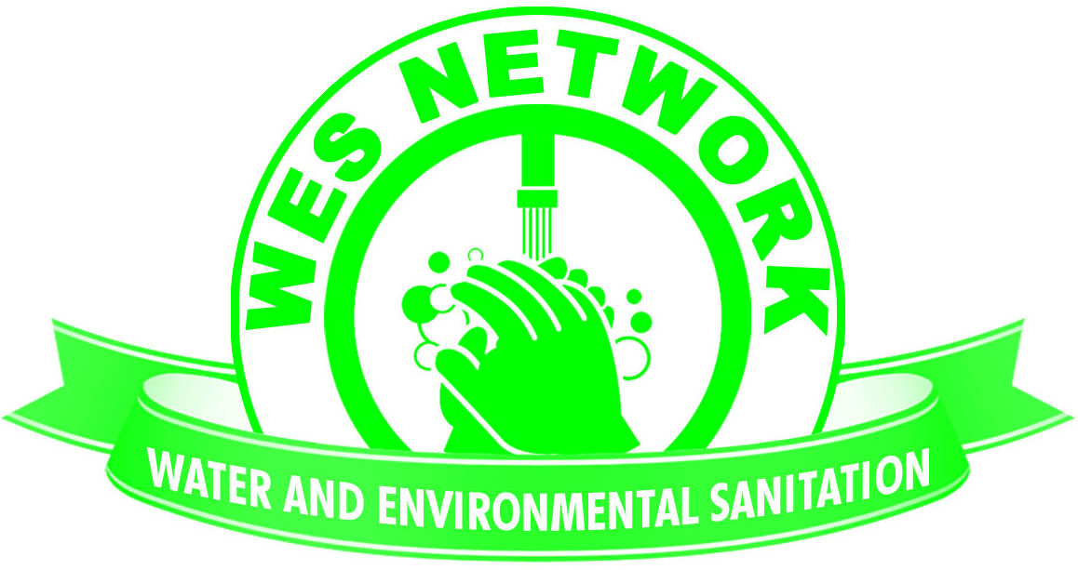

Water and Environmental Sanitation Network

2019 Malawi Performance Report for WASH Civil Society Organizations (CSOs)

SECOND DRAFT

November 2019

THE PERFORMANCE REPORT FOR THE MALAWI’S CSOs IN WATER AND SANITATION SECTOR

Under Water and Environmental Sanitation Network (WES Network)

November 2019

Foreword
The past year in the Water, Sanitation and Hygiene (WASH) sector in Malawi, has been different from the other past few years. As Civil Society Organisations (CSOs) and development partners, we continued to invest in many of the same activities as in the past- water point installation, upgrading of latrines, promotion of household latrine construction, promotion of latrines in institutions like: health facilities and schools, training of community groups, etc. Our efforts and focus have been different in the sense that our programming was aligned to the global commitment of Leaving No One Behind.
In terms of investment into the sector, the 23 CSOs that provided reports have cumulatively invested MK10.2 billion this year and have projected to invest MK5.2 billion in the `year 2020. In terms of absolute reported values, there is a downward spiral of 37% as compared to last year (2018) when the CSOs invested MK16.1 billion. The total investment into all sectors for the 23 CSOs stood at MK45.6 billion. The total number of the CSOs that had reported this year represents only 25% of the total WESNET registered members (88). This is worrisome/regrettable because, as an important constituency in the WASH sector, there is a growing need that all members value mutual accountability in all that they do within the sector, including reporting. The Sustainable Development Goals (SDGs) demand a much higher level of achievement and aspiration that call for all development partners to envision and work collaboratively towards the set SDG targets.

Since the launch of the SDGs in 2015, we have been called upon to re-envision what sustainable access to WASH services looks like and how far we are from reaching that goal in Malawi. As a sector we have been relatively slow to adapt the SDGs to Malawi’s context. The year 2019 has witnessed greater efforts at fostering collaborative behaviour among the WASH development partners, towards government-led processes and strengthened sector systems. One of the key deliverables has been the domestication of the WASH sector-wide SDG indicators.
There is evidence that in 2019, the Sanitation and Water for All task force in Malawi continued to push for conversation around strengthening the sector systems for regulation, government-led planning, accountability mechanisms, sustainable financing, and harmonising sector M&E systems. There has been a dedicated effort on improving the JSR processes through a review. Various organisations have taken part in discussing the way forward to improve how our sector collects, manages, and shares M&E information. WES Network hosted a number meetings of the Policy and Advocacy and Research and Knowledge Exchange Thematic Working Groups and managed to hold a southern Regional Chapter coordination meeting. Consultative workshops were also held towards standardizing the process for developing as well as the table of contents for District Strategic Investment Plans (DSIP). All of these are just examples of how the mindset of our sector is slowly shifting away from simply implementing WASH projects, but instead looking towards the future of sustainable service delivery and how we can achieve that together. This is the first step in changing how we think about the challenges we face, and endeavouring to strengthen the systems that are in place to ensure we have an effective sector.

The theme of this year’s Joint Sector Review, “Resilient and Sustainable Malawi through Water, Sanitation and Irrigation Development” is indicative of this shift. We cannot affect improvements in our sector without addressing the issue of accountability- both as Government and as CSOs. Never before have we been as collectively committed to making sure that the coming year is not just ‘business as usual.’ This year allowed us to shift our mindsets, but it means the year ahead needs to be one of action.

On behalf of the WES Network secretariat, I would like to call each one of us to action. Let us use the foundational discussions on important systemic challenges that were held in 2019 to lay the groundwork for greater action in 2020. In November of next year, I hope we will be able to say that we have made progress in addressing the very same challenges we report on year after year, and that we will demonstrate the progress that we have made towards the achievement of the SDGs. We should all be mindful of the fact that the first review for the SDGs is scheduled for the year 2020.

I would also like to thank, in a special way, the organisations that made time to contribute their progress reports and opinions in the formulation of this year’s CSO Performance Report. Your commitment to transparency and participation are the foundation for increased accountability in our sector. And let me encourage those that did not report to ensure that they do so next year.

Kate Harawa
Board Chairperson- WES Network

Contents
1.0 Context 9
2.0 Introduction 10
4.0 Financing and Expenditure for the Sector 12
4.1 CSO Expenditures 12
4.2 Donor Financing 13
5.0 Analysis of CSO Activities in 2019 15
5.1 DISTRICT ACTIVITY 15
6.0 OUTPUTS AND ACHIEVEMENTS 17
8.0 CHALLENGES FACED IN THE COURSE OF IMPLEMENTATION 18
8.1 POLITICAL INTERFERENCE 18
8.2 HIGH TURN OVER OF AREA MECHANICS 19
8.3 POOR COORDINATION 19
8.5 LACK OF SUPERVISION AND COMMITMENT FROM GOVERNMENT PERSONNEL 19
8.6 LOW FUNCTIONALITY OF DECISION MAKING, COORDINATION AND ACCOUNTABILITY STRUCTURES 20
8.7 DISASTROUS CYCLONE IDAI 20
8.8 DRY BOREHOLES 20
9.0 SYSTEMS STRENGTHENING BEHAVIOURS OF CSOs 20
9.1 ENHANCE GOVERNMENT LEADERSHIP OF SECTOR PLANNING PROCESSES 21
9.1.1 OBSERVATION 22
9.2 STRENGTHEN AND USE COUNTRY SYSTEMS 22
9.2.1OBSERVATION 23
9.3 USE ONE INFORMATION AND MUTUAL ACCOUNTABILITY PLATFORM 23
9.3.1 OBSERVATION 24
9.4 BUILD SUSTAINABLE WATER AND SANITATION SECTOR FINANCING STRATEGIES 24
9.4.1 OBSERVATION 24
10.0 CASE STUDIES 25
11. RECOMMENDATIONS 28
11.1 IMPROVE COORDINATION AT DISTRICT AND NATIONAL LEVEL 28
11.2 PROMOTE SANITATION AND HYGIENE INTERVENTIONS IN PUBLIC SPACES 29
11.3 ENHANCE GOVERNMENT LEADERSHIP AND OVERSIGHT AT DISTRICT LEVEL. 30
11.4 EXPEDITE REVIEW OF WASH POLICIES 30
11.5 IMPROVE MONITORING AND IMPLEMENTATION OF JSR COMMITMENTS AND STREGNTHEN COORDINATION PLATFORMS 30
12. APPENDICES 32

1.0 Context
The Water and Environmental Sanitation Network (WES Network) is a membership based Civil Society network that coordinates the work of NGOs working in the Water, Sanitation and Hygiene (WASH) subsector in Malawi. It recognizes the role of water and sanitation in economic development and poverty reduction. WES Network was established in 2005 and got registered with Malawi Government in 2011. WES Network’s head office is in Lilongwe with representation across the country by its member organizations.

WES Network as the national umbrella organization of NGOs, CBOs, Private Sector and individuals in water and sanitation sector in Malawi, and is mandated to provide annual performance reports for CSOs working in WASH sector. This report, referred to as the CSO Performance Report, serves as an accountability and performance monitoring tool for CSOs in this sector. It also serves to reflect CSO’s sector contribution.
The report is based on data submitted by the CSOs reporting on a wide range of activities across the WASH spectrum. A standard format for data collection tool used in the previous year was reviewed and distributed to CSOs. The tool intended to capture data on budgets and expenditures, areas of focus, challenges, and the major outcomes of the interventions taken.
Apart from helping the CSOs to account for their contribution, this report serves to contribute to government’s reporting system through the Sector Progress Report (SPR). As per the requirements, the CSO Performance Report forms part of the SPR to seal the progress made by the sector within the whole year.

2.0 Introduction
According to NGO board, Malawi has more than 100 Civil Society Organizations that are aimed at complementing the work of government in the WASH sector. There has been an increased number of players in the sector which has resulted in duplication and sometimes conflicting efforts in as far as project implementation is concerned by these WASH players. It was also noted that there is lack of accountability by most players. However, there has been some notable efforts by other players in the year 2019 to enhance accountability among CSOs. The annual report therefore serves as an accountability tool while also showcasing and informing the good work the CSOs are doing in complimenting government’s efforts.
Twenty-three (23) organisations provided information for the compilation of this report and out of these, local NGOs represent 37%, international NGOs (INGOs) represent 54%, and 2 academic institutions representing 8%. These two academic institutions are Mzuzu University, and the Polytechnic. Of these reporting organisations, 17 (86.4%) are paid up WESNET members while 5 (13.6%) are not.

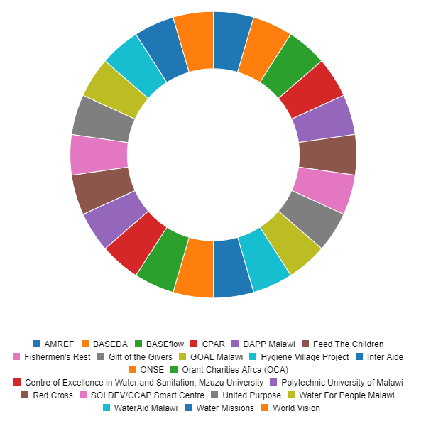
Figure 1: Organisations contributing to the report

4.0 Financing and Expenditure for the Sector
This section gives a snapshot of investments and progress made by CSOs in 2019. It must be kept in mind that the information presented is not comprehensive due to relatively low CSO report submission. The report also covers CSOs achievements and outputs as well as challenges and recommendations for the sector.

4.1 CSO Expenditures
For the operations in the WASH sector in 2019, the 23 CSOs reported projects with aggregated annual budgets of about MK10.2 billion Kwacha for various activities and have projected to invest MK5.2 billion in the `year 2020. In terms of absolute reported values, there is a downward spiral of 37% as compared to last year (2018) when the CSOs invested MK16.1. The total investment into all sectors for the 23 CSOs stood at MK45.6 billion. The total number of the CSOs that had reported this year represents only 25% of the eighty-eight (88) registered members. Only a few CSOs provided a breakdown of investments that were made to different sub thematic areas. In the breakdown it was shown that 53 percent of the total investments went to water supply, 35 percent went to sanitation and hygiene, capacity building and advocacy took 7 percent of the total investments, whilst irrigation investment was at 1 percent and Water resources management was at 3 percent whilst research and coordination were at 0.5 percent.
Below is the summary of the approximation of total investments per sub thematic area:
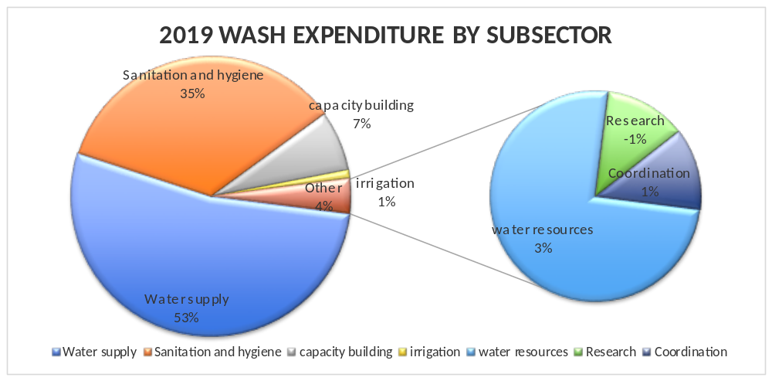Figure 2: Investment by subsectors by CSOs

4.2 Donor Financing
In past years it has been difficult to characterize all of the sector funding that is not appearing on government budgets. Reporting from CSOs has never been comprehensive, with only a portion of CSOs reporting on their financial information. Government, on the other hand, only has information about government spending and donor funding that is channelled through the government coffers for projects. This leaves an incomplete picture of how much money is invested in our sector each year.
This year, an information request was sent to 9 donor agencies to also report on which projects they funded in the Irrigation and WASH sub-sectors. We received reports from the African Development Bank, USAID, UNICEF, JICA and WSSCC. Due to various reasons cited by those agencies and the short time frame given to submit, we did not receive reports from the other donors. Other donor agencies were not contacted directly. The financial information reported by the 5 agencies was cross-checked with the information submitted by CSOs to remove duplicate information to the best of our knowledge, though some CSO reporting was inconsistent.
The total investment this financial year reported from 5 donors was MK 19,971,074,856.00. Out of the total investment, MK19,622,957,680.00 billion was invested into the WASH sector. This translates into 21% reduction in sector investment as compared to MK24 billion kwacha reported last year. Figure 5 below shows the breakdown by various donors.
Of the total amount invested in WASH by the five donors; African Development Bank invested a huge proportion of about MK 13,898,743,660.00(which represents about 71 percent of the total investments). This huge expenditure can be attributed to the Sustainable Rural water and Infrastructure project which seeks to increase the resilience of water supply systems, thorough expansion and rehabilitation and to address sanitation and hygiene issues in some few selected districts.
The AFDB is also investing considerable amounts through Northern region water board to improve water and sanitation services through Mzimba district. UNICEF and USAID activities focused on borehole drilling and rehabilitation as well as improved rural sanitation and hygiene. WSSCC funded coordination in the sector, a portion of which went to WESNET secretariat.
JICA funding focussed on technical support to the MOAIWD. There are also other components looking at methods for reducing non-revenue water for Lilongwe Water Board. There is also a component looking at a system for professional development for irrigation officers in medium scale irrigation schemes and to develop the environment for sustainable and conservation management for Dzalanyama Forest Reserve (DFR). 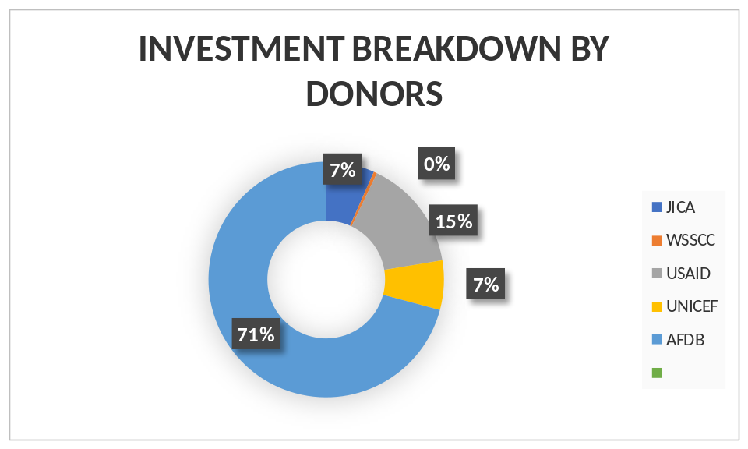
Figure 3: Investment breakdown by donors
The five donors that reported also indicated a projected budget of about MK17,895,925,924.00 in the next fiscal year. This represents a 9 percent decrease from this year’s investments.

5.0 Analysis of CSO Activities in 2019
During the reporting period, CSOs made tremendous individual and collective progress in service delivery. Even with only about less than half of the allegedly active WASH organizations reporting a wide geographical and thematic spread of CSO led activities was registered. It is worth noting that 54.5 percent that have reported are international NGOs, 31.8 percent local NGOs and 9.1 percent are academia. About 86.4 percent are paid up WESNET members.

5.1 DISTRICT ACTIVITY
All the 23 organisations that reported specified the districts in which they are active. On average almost each district has at least two CSOs active and the median was about 3 organizations active. Dowa was reported to have the most active CSOs with eleven, followed by Lilongwe, Zomba and Chikhwawa with each having about ten active CSOs. Mwanza and Likoma were reported to have fewer CSOs active in WASH. But it is pleasing to know that Likoma has now some WASH CSOs active as in the last reporting year no CSO reported to have been working in Likoma.
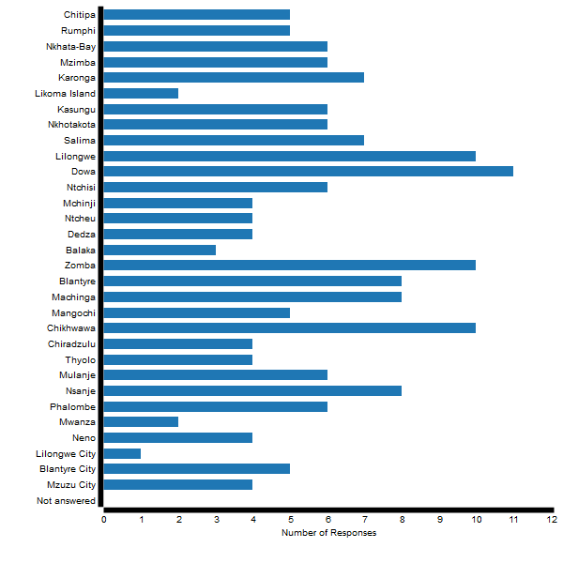
Figure 2: number of WASH NGOs per district
Regionally, about 17 organisations reported that they have projects in the southern region, whilst 15 in the central region and 9 in the northern region.
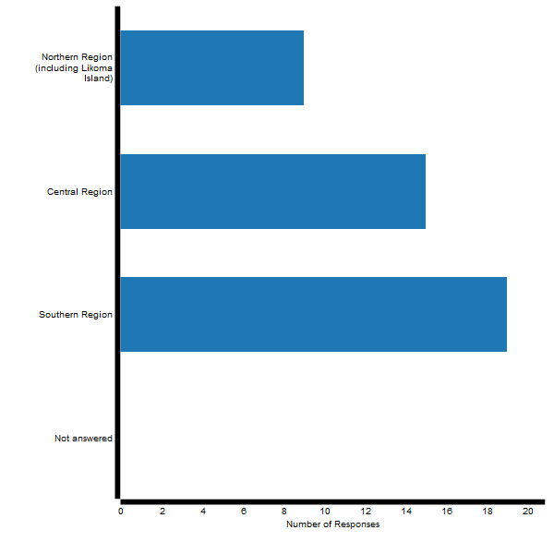
Figure 3: Number of WASH NGOs per region

6.0 OUTPUTS AND ACHIEVEMENTS
Among organizations that submitted reports almost all provided specific details on their organization achievements in the past year. There were a lot of indicators for these interventions but they have been grouped into ten groups according to the type of intervention. The interventions included construction of water points, rehabilitation of water points, mapping of Water points, building of hand washing infrastructure, construction of latrines and improvement, training of entrepreneurs, training of area mechanics, hygiene advocacy and training of water point committees. There were also other indicators but to avoid making the report bulky, it can be concluded that, building of toilets was the highest recorded intervention, seconded by building of hand washing facilities and that training of water point committees was the lowest recorded intervention with about 145 water point committees trained.
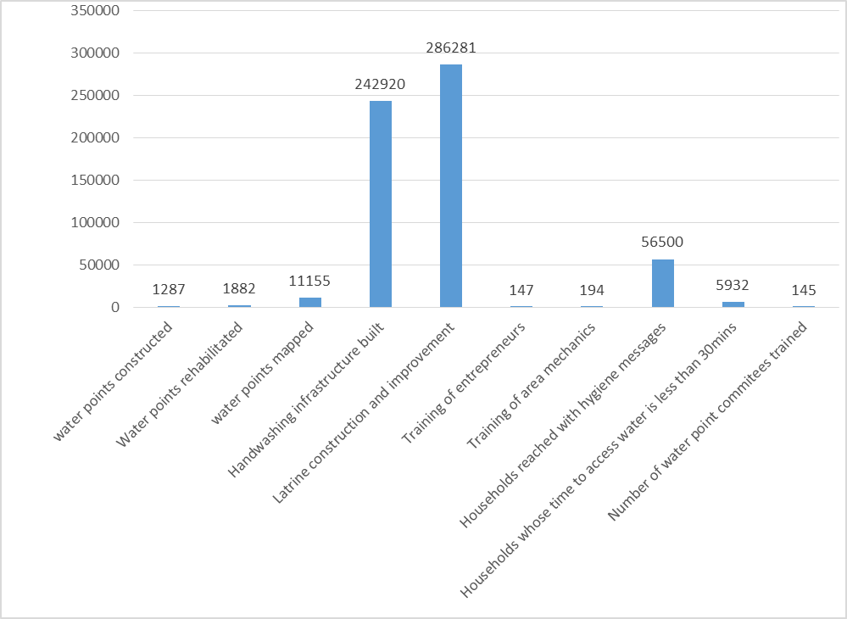
Figure 3 Outputs of intervention by 23 organisations

CHALLENGES FACED IN THE COURSE OF IMPLEMENTATION

8.1 POLITICAL INTERFERENCE
Some CSOs have reported that politicians have been telling communities not to pay for water or even contribute for operations and maintenance fee even though government guidelines state differently. In some communities councillors and aspiring MPs have been buying spare parts for communities to be used during operation and maintenance. Some NGO also reported that politicians provided maintenance subsidy for water points in some areas as a tool for gaining votes. All this poses huge threats to sustainability of water points in such communities. Efforts to promote community contributions towards water point maintenance have proven futile in such areas and thus undermining sustainability of water points.

8.2 HIGH TURN OVER OF AREA MECHANICS
There are not much incentives for area mechanic when carrying out their operation and maintenance services. Most area mechanics quit their job after a short time and leave communities desperate in servicing of water points once it has been broken. Replacement of area mechanics takes too long despite communities reporting.

8.3 POOR COORDINATION
Just like in the previous reports, the lack of coordination has also been reported by a number of CSOs as ac challenge during implementation of projects this year. Some NGOs reported that attempts to synergize with other organisations with similar project goals proved futile. This was attributed to the fact that achievement of internal goals or aims or plans holds more prominence and value in the sector than multiparty collaborations that exemplify noble ideals. Others also reported that NGOs or CSOs rarely interacts with government personnel at district level and this has resulted in duplication of efforts and lack of following government regulations by CSOs. Some NGOs also reported the lack of knowledge sharing platform at district level where WASH CSOs would learn from each other and improve their programming.

8.5 LACK OF SUPERVISION AND COMMITMENT FROM GOVERNMENT PERSONNEL
CSOs also reported of minimal efforts from government to supervise the work of NGOs and other stakeholders at district level. CSOs also reported the lack of proper supervision from within government lines i.e. the lack of proper supervision of water monitoring assistants to ensure that they carry out their work accordingly. Other NGOs also reported of unavailability of key government officials to support WASH interventions during actual implementation more especially when the meeting or training is taking place within the district.

8.6 LOW FUNCTIONALITY OF DECISION MAKING, COORDINATION AND ACCOUNTABILITY STRUCTURES
Some CSOs also complained of dormancy of coordination and accountability structures like sector working groups, technical working groups, district coordination team and donor partners. These forums were supposed to be meeting regularly to enhance coordination and accountability in the sector but the view from NGOs is that there have been partially active in the past year. There have also been no incentives & or sanctions meted out to those responsible for ensuring that these structures or platforms perform. CSOs also complained of weaker leadership of the WASH sector on the part of government which is linked to the above point and the fact that WASH is eclipsed by Agriculture and Irrigation in the Ministry of Agriculture Irrigation and water development.

8.7 DISASTROUS CYCLONE IDAI
CSOs also complained that Cyclone Idai floods destroyed a lot of WASH investments made, especially in the southern region. Floods washed away river crossings for piped water systems hence making many GFS taps non-functional. The floods also destroyed gains made at household level in sanitation through destruction of household’s toilets

8.8 DRY BOREHOLES
Deforestation activities have influenced water table issues. This evidently affects the performance of the water points. In most cases NGOs have found it difficult to extract water due to low water table as more areas are drying up leading to low water yield during exercise of water extraction.

9.0 SYSTEMS STRENGTHENING BEHAVIOURS OF CSOs
As our sector works to localize SDG6 and how Malawi can work towards its achievement, we cannot ignore the fact that in order to achieve sustainable access to WASH services we need to strengthen the systems that support service delivery in the long term.
The Sanitation and Water for All (SWA) platform is a multi-stakeholder partnership committed to achieving universal, sustainable access to WASH services by 2030. SWA partners have identified four key ways in which countries can improve the way that government and development partners work together to achieve greater development effectiveness. It posits that if four-key collaborative behaviours are adopted, collectively we can improve long-term sector performance. These four behaviours are to: Enhance government leadership of sector planning processes; Strengthen and use country systems; Use one information and mutual accountability platform; and Build sustainable water and sanitation sector financing strategies.

It is with these behaviours in mind that organisations were asked to characterise practices that indicate whether they are contributing to systems strengthening or if CSOs are simply operating in parallel to government and other country systems. The following key observations were made:

9.1 ENHANCE GOVERNMENT LEADERSHIP OF SECTOR PLANNING PROCESSES
18 organisations of the reporting CSOs claim to work with district government as a key stakeholder 5 organisations reported national level ministries as a key stakeholder in their work. Eleven (11) organisations reported using specific district plan documents such as DSEPs, DDPs and DSIPs to inform priorities for planning within their organisations. Some NGOs cited general WASH meetings as having influenced their decision making.
Ten (10) of the reporting organisations made reference to national planning documents in setting of WASH priorities such as MDGS 3, NSHS, NRWSIP and MDHS. Eight (8) organisations stated that their strategic plans informed decision making but it is unclear how many of these CSOs rooted their plans in government led planning processes. Welt Hunger Hilfe (WHH), Water for people and WaterAid have developed a partnership of facilitating the development of DSIPs in some selected districts. WESNET secretariat also facilitated the development of WASH plans in Kasungu, Mwanza and Thyolo district councils.

9.1.1 OBSERVATION
CSOs are engaging with government at different levels but most of this engagement is surface level. CSOs attend DEC meetings and other government meetings. CSOs also use documents that government has developed for planning, but it remains to be known if CSOs use the data comprehensively as a guideline for planning. Fewer organisations have been accessing official district planning documents to inform their plans. In this reporting year just like in the last reporting year, the complaint from government has been that few organisations have shown willingness to engage in joint planning at district level but rather come with projects they expect to implement with government cooperation.

9.2 STRENGTHEN AND USE COUNTRY SYSTEMS
Country systems may be considered as those that fall outside of temporary NGO action- primarily government, private sector, community, or regulatory/coordination structures. 7 of the reporting organisations indicated to have trained key stakeholders at district level like area mechanics, Water point committees and entrepreneurs. Mzuzu University also trained WASH staff from various institutions on Monitoring and Evaluation. Water for People supported Wesnet secretariat to carry out NGO coordination through direct support to Wesnetwork for coordination and knowledge sharing activities. Wesnetwork secretariat also hosted a number of coordination meetings and the network was highlighted as a key strategic partner. Water for people, WaterAid and Welt hunger hilfe have developed an alliance for ensuring that some selected districts develop DSIPs.

9.2.1OBSERVATION
Majority of CSO activities still, remain focused on direct service delivery in parallel to country systems. CSOs are excelling more in terms of systems strengthening at community level, where direct implementation can strengthen the capacity of community groups, less attention in general is still being given to directly strengthen government capacity as an outcome area. Even though coordination is continuously mentioned as a challenge in the sector few organizations are willing to support the costs associated with coordination.

9.3 USE ONE INFORMATION AND MUTUAL ACCOUNTABILITY PLATFORM
Eleven (11) of the reporting organisations claimed to have accessed public WASH data, but the information was sourced from many sources. Some of the data sets accessed include district social economic profiles and DSIPs. Some NGOs also accessed M-WATER information and Madzi alipo database. CSOs also obtained information from NSO, MOH, MOAIWD and Donor partners. Only 7 NGOs referenced to accessing data from district offices. 15 of the reporting organisations collected and shared information with other entities such as government, NGOs and donor partners. CSOs shared information with government. The information that was shared included; the number of area mechanics in a specified district, sanitation and water coverage data, WASH facilities constructed, water point committees trained, WASH coverage in schools and health centres as well as monitoring and evaluation tools used in operation and maintenance of water points. Some NGOs also shared project implementation reports with government and DPs as well as WASH expenditure data to UNICEF for their WASH public expenditure review study. Base flow and Fishermans rest input data to their online platform for different stakeholders to use. Research publications from Mzuni and the polytechnic were also shared for use.

9.3.1 OBSERVATION
There is poor access to comprehensive data sets in the WASH sector. While some NGOs managed to get pieces of information from various CSOs there is no center point where NGOs would collect information. Most of the data that that CSOs claim to report on is on project reports and specified to an NGO. The difficulty in harmonizing information at national and district level so as to validate and make reliable WASH information accessible to the public still remains. There is a need to ensure the fast tracking of efforts to harmonize data collection and management. The SWA taskforce should spearhead this process.

BUILD SUSTAINABLE WATER AND SANITATION SECTOR FINANCING STRATEGIES
Out of the 23 organisations reporting this year only Water for people indicated to have funded some activities directly through government. The sub-thematic areas that were funded included water supply, capacity building, planning, monitoring and evaluation activities. The funds were used to rehabilitate non- functional boreholes, conduct CBMs , community promotion as well as DCT meetings. The district councils that benefited from these include; Blantyre city council, Chiradzulu and Chikhwawa. Approximately K10, 000, 000.00 was sent directly to government account. Water for people are also carrying out a project that looks at metering rural water supply systems in a bid to ensure that communities pay for water according to quantities being consumed. A number of NGOs also report to have trained a number of WASH entrepreneurs in a bid to increase private actors participation in the WASH sector.

9.4.1 OBSERVATION
Just like the 2018 report, CSOs are still unwilling or unable to fund activities directly through government due to organizational policies. CSOs recognize that district WASH offices need a higher allocation of resources from the central government level but there are not much coordinated efforts by CSOs at both national and district level on joint financing of government activities. WASH NGOs need to be an active party in ensuring that at both the national and district level joint financing arrangements are drawn as this will ensure that WASH spending is well coordinated. There should also be greater involvement of the private sector and development of tariffed mechanisms to ensure that sustainable Water and sanitation sector financing strategies are built.

10.0 CASE STUDIES

CASE STUDIES OF INNOVATIVE APPROACHES
- MAXIMISING USAGE OF WATER RESOURCES- (THE ATERSIAN WELL)-THE CASE OF BASEFLOW
Though in its early stages, the artesian well project in Lirangwe, Blantyre, is providing an exemplar for how we could maximize water resources, beyond mere consumption, to more productive uses as one way of creating a meaningful incentive for communities to maintain their water supply systems. This is in line with international thinking wherein the Rural Water Supply Network (RWSN) chair Kelly Ann Naylor from UNICEF stated, in the June Issue of RWSN Update, that the water sector globally needed to transform people’s lives by harnessing water infrastructures to “cater for a wider spectrum of rural needs - domestic supply, household gardens, rural businesses, and rural transformation as well as drinking water”. She further added that this will require fierce collaboration where rural water practitioners join hands, work across disciplines and ‘development themes’ to address gaps in achieving the Sustainable Development Goals. Our work on the artesian well project in Jordani Village, supported by the Scottish Government’s Climate Justice Innovation Fund and implemented in partnership with University of Strathclyde, is a petri-dish for testing this bold idea. As at the time of submission of our report, the project was already re-directing the artesian water toward fish-farming, irrigation, tree nurseries as well as drinking water. Learning visits to the project site will be organised in the New Year for other WASH NGOs to appreciate the work.

B. CARBON FINANCING FOR SUSTAINABILITY-THE CASE OF UNITED PURPOSE
UP has partnered with CO2balance, to generate, market and sell carbon credits from its borehole program in Dowa and Kasungu. This partnership seeks to develop innovative sustainable community safe water projects generated from carbon financing.
Communities who have new boreholes or their boreholes repaired no longer have to boil water to purify. The behavioural change reduces tons of carbon emissions, which are measured as carbon credits. One carbon credit is created when an equivalent of one metric ton of co2 is prevented from entering atmosphere. The carbon credits are tradable on the market. They are sold to buyers that want to reduce their carbon foot - prints or improve environmental stewardship. Carbon financing for water is an upcoming innovation, which is gaining ground in most countries.
Starting on a trial basis, we ‘Registered’ 71 boreholes under Gold Standard, each reducing 10,000 tonnes of carbon emissions in 2017. UP registered 191 more boreholes to expand the project size and issued an additional 290,000 carbon credits in 2018 & 2019.To date, these projects have issued approximately 300,000 carbon credits, some of which have been sold and some that are still on the market. The project is replicable and scalable and UP continues to register more boreholes onto the program.
UP realized first ever carbon revenues in 2017, put into borehole sustainability fund to provide last defense for water point functionality. A case in point is Tchawale borehole, the first ever borehole to benefit from carbon funds through a major rehabilitation. The carbon revenues are also funding wider community development initiatives through our health care development initiatives in Dowa District and a dedicated Officer responsible for borehole monitoring and ensuring ODF sustainability through community follow ups. Simply put, the carbon finance borehole is innovatively unlocking the much needed funding apart from keeping the water flowing always.
C. SYSTEMS STRENGTHENING INITIATIVE-THE CASE OF WATER FOR PEOPLE
Water for People in collaboration with WaterAid (WAMA), Welthungerhilfe and World Vision International are promoting a system strengthening approach of supporting district councils to attain universal access to WASH by 2030 and the approach is called District Wide Approach. In this reporting period, through the collaboration 5 districts have been adopted as DWA districts as follows; WVI (Ntcheu), WAMA (Machinga & Zomba), WHH (Dedza) and Water for People (Chiradzulu).
E. AFD 2 SENSOR DISTRIBUTION AND INSTALATION-THE CASE OF FISHERMANS REST
With over 100 agencies on the MAMS database through collaboration and cooperation, the expectation is to install sensors across Malawi, targeting vulnerable, and not easily accessible communities to assist with a more sustainable water resource. This is to reduce expensive, repetitive water mapping services. This is a huge project. Not just for us, but for the entire water sector. Not only are these sensors capable of transmitting data from remote, low connectivity areas, they’re also smart enough to learn the behavior of a water point and report immediately when there is significant behavior change. This technology allows who implements a water project to be accountable for it, to respond when there is a breakdown and to make sure that people who receive clean water keep having access to clean water.
D. ACCELERATING ODF ATTAINMENT-THE CASE OF DAPP MALAWI
For the past year we managed to declare 7 traditional authorities open defecation free, we worked with 2 T/As in Zomba and 5 T/As in Machinga. The achievements were registered within 10 months of implementation, this happened because of the structures that we are using as a project where we have direct wash field officers responsible for specific number of villages and these field officers train 10 village action group members as a community structure in each village who are responsible for organizing actions to mobilize their communities to construct sanitation facilities.

11. RECOMMENDATIONS
Looking at the challenges that WESNET members have experienced within the year the following recommendations have been made. Some of the recommendations proposed from this year are not very different from last year`s report. Analytically, it can be concluded that that some of the challenges CSOs faced in 2018 have repeated themselves in this year. However, there are still some positives changes that have been witnessed in the sector in this reporting year.

11.1 IMPROVE COORDINATION AT DISTRICT AND NATIONAL LEVEL
Just like in the 2018 report it was cited that there is often duplication of effort for NGOs implementing similar projects in districts that has led to resource waste amongst the NGOs. The 2019 report has also revealed that many partners are frustrated by challenges to do with coordination, indicating very little progress on this issue. (This seems like a song in the sector). In the 2018 report we pointed out that, “It is easy to point a finger at the other organisation, the government, the community, but the truth is- the responsibility is on each and every organisation and individual to improve coordination” Wesnetwork CSO performance report 2018. This year we would like to emphasise the same three points just like in the 2018 report.
Firstly, there is a need for WASH CSOs to seriously consider the coordination aspect in their programs. In planning stages, all CSOs need to consider how their plans will be in line with District Development or Investment Plans, as well as National policies and guidelines. They should also consider the plans of other organisations to avoid duplication of efforts and wastage of resources.
Secondly, WASH CSOs should become more active members of the existing coordination structures in the sector. There are Regional Chapters under WES Network where different NGOs within the region come to the same table to share and learn success stories from others, as well as to identify overlap in activities. There are Thematic Working Groups under WES Network to coordinate on policy and advocacy issues, as well as to share knowledge and best practices with each other. WES Network will be engaging its members in different districts to facilitate these processes.
Thirdly, most organisations and government are complaining about coordination as a challenge but there are only a few organisations that dedicate budget lines to coordination activities, whether they are stand-alone coordination activities or integrated as part of the planning or implementation phases of a project. Coordination is relatively inexpensive, but it still has both a time and resource cost that need to be budgeted for. In fact, the cost of not coordinating is much higher.

11.2 PROMOTE SANITATION AND HYGIENE INTERVENTIONS IN PUBLIC SPACES
Most NGOs are focusing their sanitation and hygiene projects at community level focusing on households. This approach has led to more public spaces like health centres and markets attaining unsatisfactory levels of sanitation. Therefore, there is a need that WASH CSOs put more focus in ensuring that public spaces also attain satisfactory sanitation levels. The National sanitation and hygiene technical committee could also promote such an approach by ensuring that a Traditional Authority is declared ODF if both communities and public spaces have toilets that are cleaner and with handwashing facilities.

11.3 ENHANCE GOVERNMENT LEADERSHIP AND OVERSIGHT AT ALL LEVELS.
As raised above, coordination remains a significant challenge in the sector. However, there are currently no incentives and perceived values in NGOs collaborating in the field. Which is why, more government oversight and leadership at district and national levels should be encouraged. NGOs that do not align with the district priorities or guidance should be held accountable rather be left to their devices as is currently the case.

11.4 EXPEDITE REVIEW OF WASH POLICIES
Much as government has put both the sanitation policy and National Water policy for review, there is a feeling amongst most CSOs that the process for the actual policy review/development needs to be expedited. Both policies are very outdated and there is a need that they be replaced with new ones as quickly as possible. This will ensure that NGOs interventions are ably guided.

11.5 IMPROVE MONITORING AND IMPLEMENTATION OF JSR COMMITMENTS AND STRENGTHEN COORDINATION PLATFORMS
Every year, during the Joint sector review meeting, there are sector commitments that are allocated for different stakeholders to achieve. There is a need to make sure that there are intensive follow ups being made to those responsible for the “promises” and that new commitments are developed upon the implementation of the earlier commitments. There is also a need to make sure that there is the fully functioning of decision making, accountability and coordination platforms in the sector. This will enhance progress towards achievement of the WASH sector goals.
  - IMPROVE AND HARMONISE A SECTOR M&E SYSTEM
In the 2018 CSO report this issue was also well emphasized. Last year’s report explicitly recommended that the Government of Malawi in conjunction with WES Network should ensure that an effective, harmonized M&E system is developed for the sector. This year most organisations also reported that accessing publicly available and reliable WASH data in Malawi is still difficult. The SWA National Task Force, which is co-chaired by Ministry of Agriculture, Irrigation, and Water Development and the Ministry of Health with WES Network as the secretariat will continue the process of harmonising M&E systems by bringing organisations together to understand what is on the table and what needs to be done to achieve this goal going forward. There is thus a need to fast track the process of harmonizing M&E systems in the sector by making a final decision on the approach for a consolidated Water Sector MIS. Members of the WESNETWORK will have to actively participate and support the review process.

12. APPENDICES
APPENDIX 1
ORGANISATIONS CONTRIBUTING TO THE REPORT

ORGANISATION | 2019 PAID  Y/N
AMREF | Y
BASEDA | Y
BASEflow | Y
CPAR | Y
DAPP Malawi | Y
Feed the Children | Y
Fishermen’s Rest | N
Gift of the Givers | Y
GOAL Malawi | Y
Hygiene Village Project | Y
Inter Aide | Y
ONSE | Y
Orant Charities Africa | Y
Centre of Excellence in Water and Sanitation, Mzuzu Uiniversity | Y
Polytechnic, University Of Malawi | N
PRDO | Y
Red Cross | N
SOLDEV  United Purpose | N  Y
Water for People | Y
WaterAid Malawi | Y
Water Missions | Y
World Vision | Y

APPENDIX 2
DONOR AGENCIES CONTRIBUTING TO THE REPORT
INSTITUTION | ACCRONYM
Water supply and sanitation collaborative council | WSSCC
African Development Bank | AFDB
United States Agency for International Development | USAID
United Nations Children Fund | UNICEF

LIST OF CSOs ACTIVE IN EACH DISTRICT
APPENDIX 3
The table shows organisations that reported activities in each of the districts
DISTRICT | ACTVE CSOs
Chitipa | MZUNI, SOLDEV, Feed the children, Water missions
Rumphi | MZUNI, SOLDEV, Feed the children
Nkhata-Bay | MZUNI, SOLDEV, Feed the children, World vision
Mzuzu | SOLDEV, Mzuni
Mzimba | SOLDEV, Feed the children, Red cross
Kasungu | CPAR, Water Missions, WaterAid, Inter Aide, World vision
Dowa | CPAR, Orant Charities Africa, WaterAid, United Purpose, Inter Aide
Lilongwe | CPAR, Hygiene village Project, Water Missions, Red cross, WaterAid, ONSE, World Vision
Zomba | Hygiene Village Project, AMREF, DAPP Malawi
Mulanje | Hygiene Village Project, ONSE
Blantyre | Hygiene Village Project, Polytechnic University of Malawi, Water for People, Fishermen’s Rest, Gift of Givers
Karonga | Water Missions, Red Cross, ONSE
Salima | Red Cross, Inter Aide, ONSE, World vision
Nkhotakota | WaterAid, Inter Aide, ONSE
Chikhwawa | United Purpose, Polytechnic; University of Malawi, AMREF, Water for People, Gift of Givers, GOAL Malawi,
Thyolo | United Purpose
Chiradzulu | United Purpose, Water for People, World Vision
Mangochi | Polytechnic, University of Malawi
Machinga | AMREF, DAPP Malawi, GOAL Malawi
Ntcheu | Fishermen’s Rest, World Vision, BASEDA
Balaka | Fishermen’s Rest, World Vision,
Nsanje | Fishermen’s Rest, Gift of Givers, GOAL Malawi
Neno | DAPP Malawi, World vision
Mwanza | Redcross

PRDO reported through a manual form hence the miss in the above diagram

